Preschool and childcare clubs Newsletter

Thank goodness the sun is shining, (some of the time anyway!!). We will break up for the Easter Holiday on Friday 4th April at 1.15 and reopen on Tuesday April 22nd, 2025, following the bank holiday. Inset days are set by North Hinksey School and a full academic year calender is available on our website and North Hinksey School website.
Staff News…You may have noticed a few young new faces amongst our team. We have had two lovely students from Matthew Arnold with us this week, both of whom came to this Preschool and some of us were their key people! As always, your children have welcomed them and enjoyed having a couple of extra adults to talk to, play with (sit on!), whilst these young people learn what the realities of working with children are.
We have also managed to recruit a new key person who will start with us on May 7th 2025, but more about them in the future.
School Merger… Many Thanks to all you that turned out to vote. The vote was positive and we are now moving forwards with merging. Our last day operating as North Hinksey Preschool and Childcare Clubs will be at the end of the summer term and the charity will be closed on August 31st. Then it will be reopening as part of the school as a School based Nursery at the beginning of the September term. As soon as I have any more details, I will share them with you. We are working with Hannah Forder-Ball (Executive Head and Oxford Schools Diocese Trust in setting up the new provision and the Tupe of our staff team across to School. As a team we are excited to see how this develops and are hopeful for the future of the setting. As always, we intend to provide the best care, education, experiences and service for young children and their families. We are experiencing many applications for sessions. Do tell your friends to get a place on our waiting lists, especially as the government funding is extending to 30 hours for Children of all eligible working parents from September! I am happy to show people around if they call 01865 794287. When they are on our waiting list they will be kept up to date with developments regarding our merger.
Weather and Clothing…Please, as always make sure your child comes to Preschool with appropriate clothing to our ever-changing weather! At the moment, they may need coats and Sun hats. If it is going to be hot, they may need sunscreen too!
On warm days we have lots of water play and your children will need changes of clothing for that too, and if they are toilet training, we need spare socks, shoes as well as pants and trousers. The team have done a truly amazing job with toilet training, alongside you as parents and we only have a couple of children in nappies now most days, which is brilliant! I hope you found the recent bottom wiping information interesting as well! There is so much in the papers about children going to school in nappies and it would be great if we could manage to support all our families in the life skill step.
School places… After Easter you will know which school your child is going to. Please let me know when it is confirmed. As you know we do small group work with the children so we will group children with their cohort where we can. I would also like to offer a catch-up with your key person, to anyone that would want one (just 10-minute slots). We could do this face to face or online, whatever suited you. You may not feel the need but please do ask us anything you are concerned about as the time approaches. Email me, catch me a collection, or drop off.
Lastly…As usual, if you have any concerns or would like to discuss anything further, please feel free to contact me.
Ruth Nhps.manager1@gmail.com Telephone 01865 794287


I have been asked to share this! Although we are not taking part in this event this time you are all very welcome and you may see some of us there of us there ourselves!

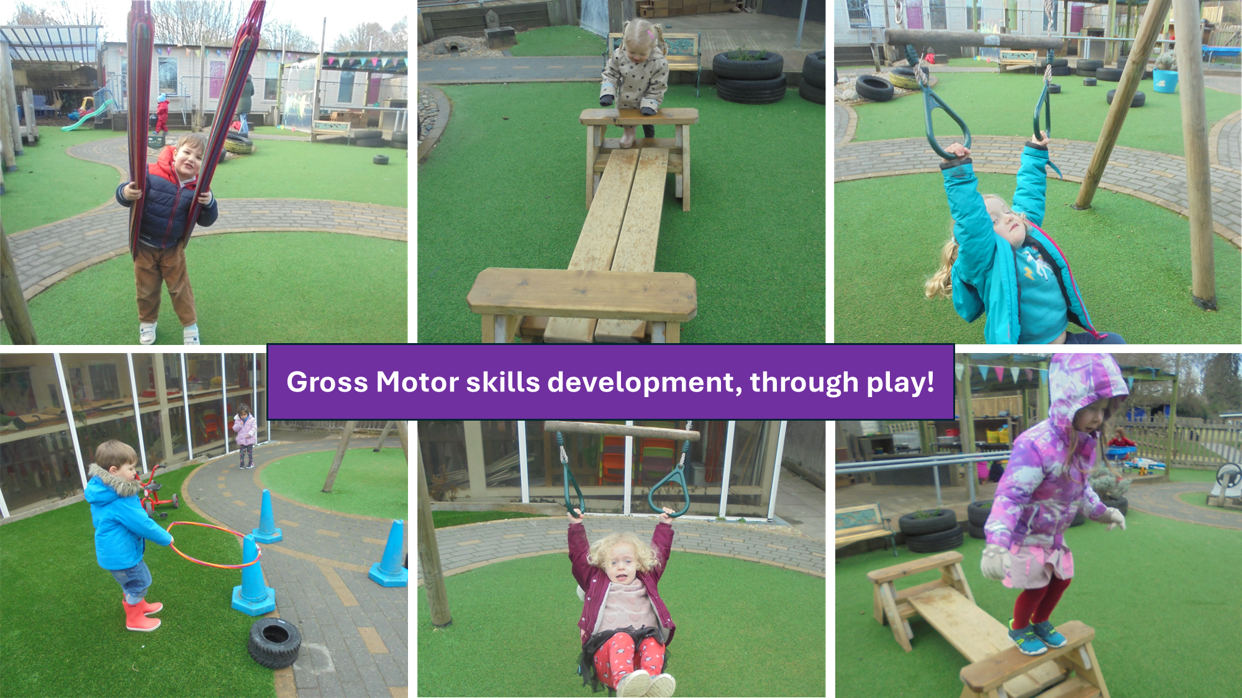

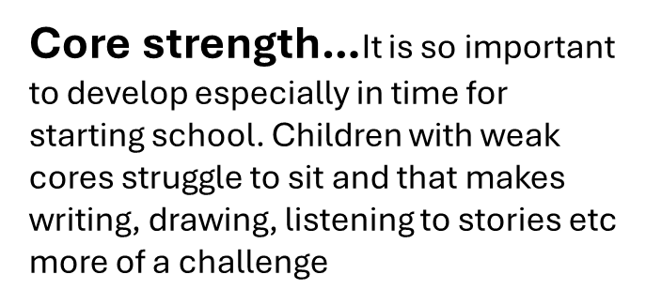
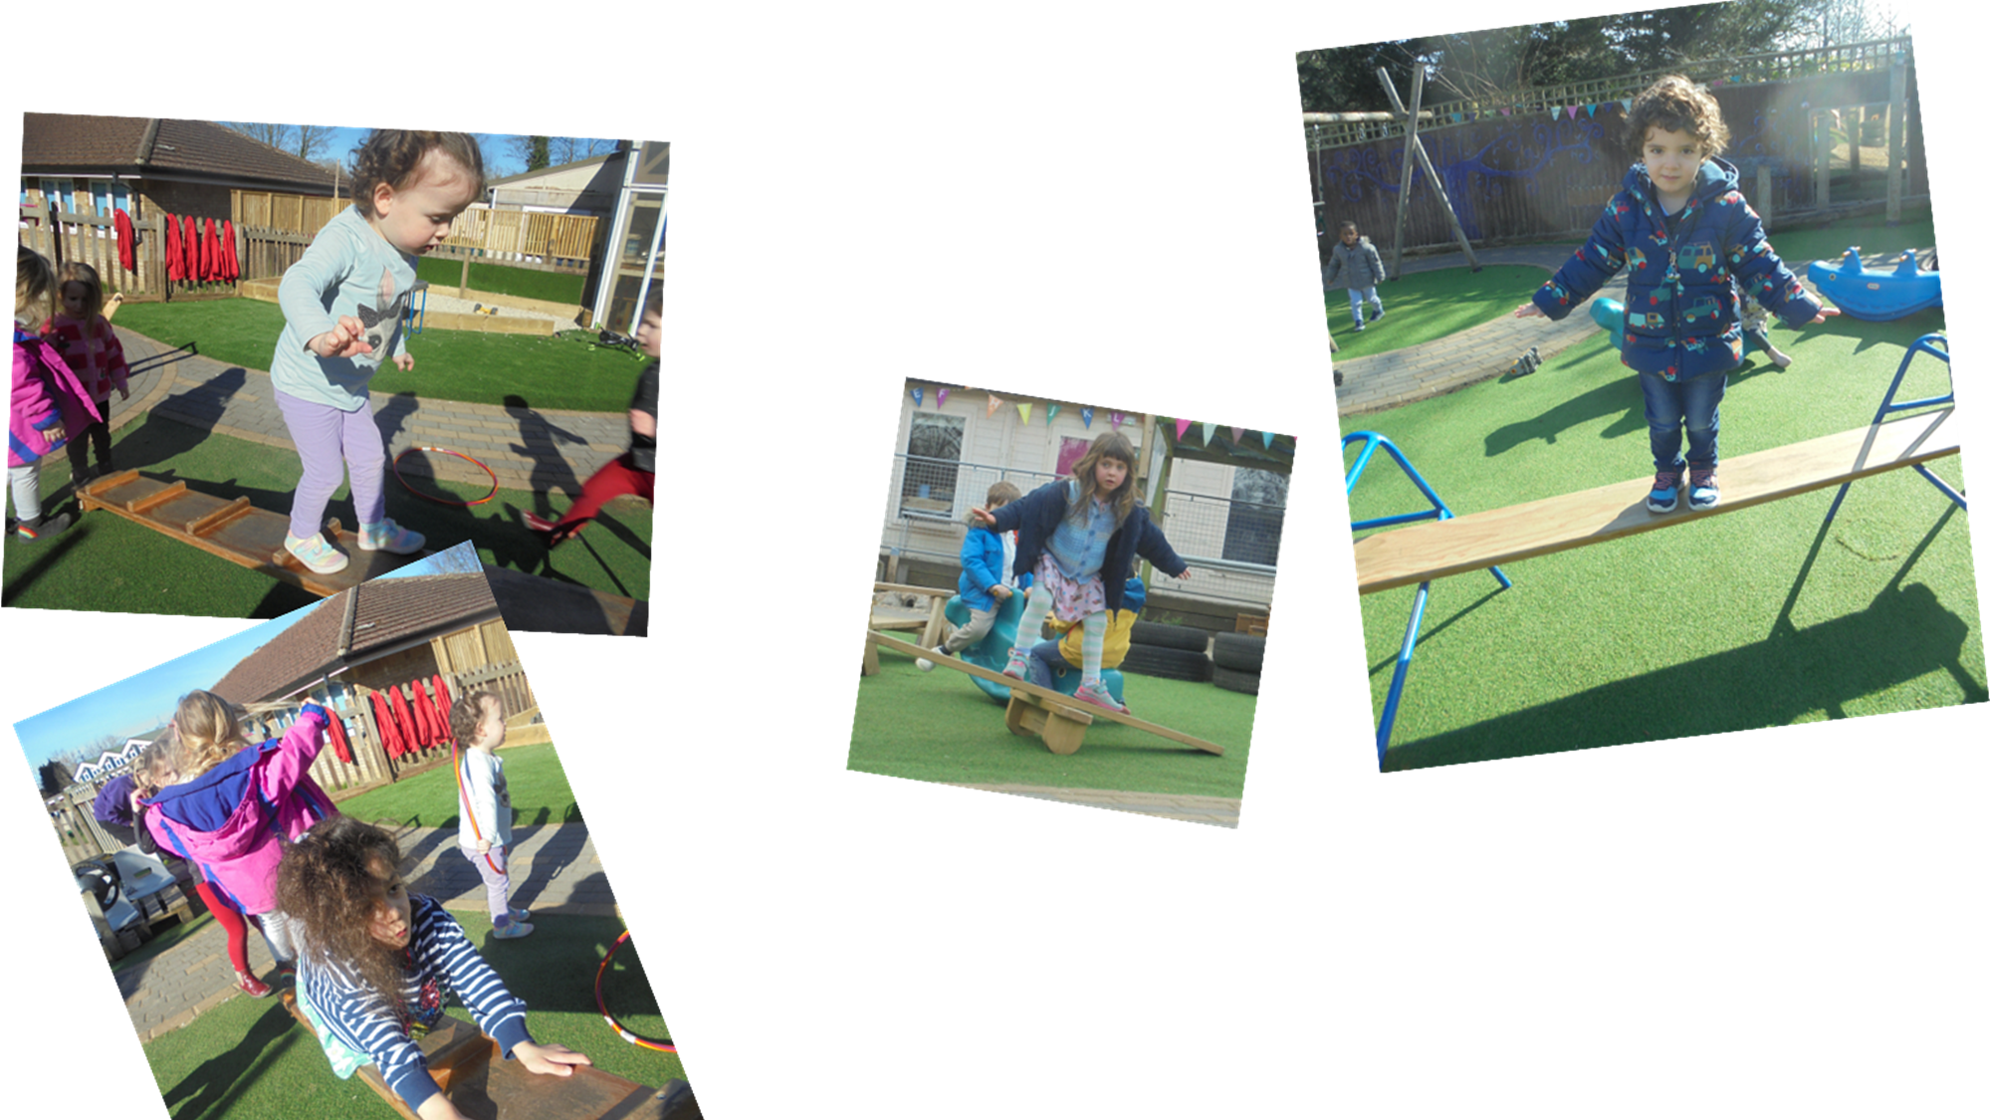
Balance… This month we have been doing lots of Gross Motor
Practice. Balance is an important skill, and the children have become more confident in their large movements. It is also good for their self-esteem and self-confidence as well as their judgement of risk. What do they feel comfortable doing? Working out different ways of doing things too!

